TOPPERS in the NPTEL Online Certification Exam conducted by IIT Madras during October 2025.
Very proud of you dear professors and students
Sl. No | Name of the Faculty /Student | Photo | Course Name | Status
1. | MR.SHAKIL AHMED A AP/ECE | 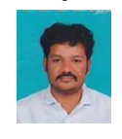 | Digital Circuits | 
2. | DR.ISAI VANI M |  | System Design Through Verilog
3. | MR.CHANDRU P AP/MECH |  | Technical Communication for Engineers | 
4. | Mr.Aravindraj HOD/EEE |  | Electronic Systems Design: Hands-on Circuits and PCB Design with CAD Software
5. | MR.KOTHALAMUTHU R AP/MECH |  | Manufacturing Systems Technology I & II | Successfully Completed
6. | Mr. ARUNACHALESHWARAN J  III Year ECE |  | Digital Circuits | Successfully Completed
7. | JEYA KUMAR L.K  III Year ECE | 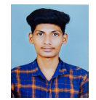 | Digital Circuits | Successfully Completed

TOPPERS in the NPTEL Online Certification Exam conducted by IIT Madras during APRIL 2026
Sl. No | Name of the Faculty /Student | Photo | Course Name | Status
1. | Dr.R.Sivaranjani  PROF/ECE | 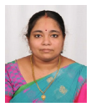 | Assessment of Student Performance  92%
2. | Ms.R.ASWINI  AP/ENGLISH | 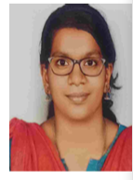 | Methodology of Educational Research
3. | Ms.E SELVAMAHALAKSHMI  AP/ECE | 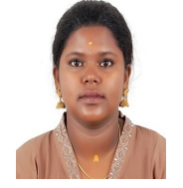 | CMOS Digital VLSI Design | Successfully Completed
4. | Ms. GOWRI ANU KRISHNA  IV YEAR MECH | 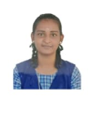 | PRODUCT DESIGN AND DEVELOPMENT
5. | Ms. GOWRI ANU KRISHNA  IV YEAR MECH |  | PRODUCT DESIGN USING VALUE ENGINEERING
6. | Ms. S SANGEETHA AP/ECE | 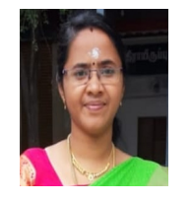 | Microprocessors and Microcontrollers
7. | Mr.T VIJAYA RAGHAVAN | 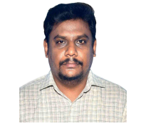 | Air Pollution and Control | Successfully Completed
8. | Ms,A BADRUL MUFSIRA | 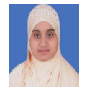 | Data Mining for Decision Making

